**Individual Contribution (Web API Development Project)**

**Project name:** NSVBank

**Name:** Navjot Singh Virk

**Student Number:** x13112406

**My Github Repo for the project**: <https://github.com/Virksaabnavjot/NSVBank> and other team members have access to it.

* Textual description of the problem and the proposed solution part in the Introduction.
* Me and Valentin: We did the ERD Diagram together.
* Most of the Coding for the project (individual contributions can be seen here: <https://github.com/Virksaabnavjot/NSVBank/graphs/contributors> )

Including from the start of the project.

* I set upped the whole project base to start with mentioned in this document - <https://github.com/Virksaabnavjot/NSVBank/blob/master/documentation/Jersey%20Web%20API%20Development.pdf>
* Solution Architecture Design
* Package and File Structure in the beginning and some changes were made later as required by the project.

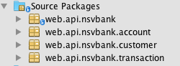

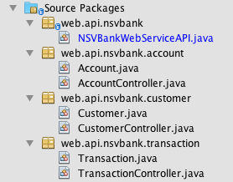

* Set upped the Client by following the material available on Moodle.